Guided Exploration 02: Abstractions, Encoding, Internet and Cybersecurity

Points: 30
Due Date: See Canvas.
Work will be accepted up to 24 hours after the due date with a 10% penalty. Meaning if you turn it in at 12:01 am of the next day you will be deducted 10% of the total points from your score. If the assignment is more than 24 hours late, it will be a 0.

Purpose: This guided exploration allows students to explore fundamental computing concepts, including data encoding, the Internet’s structure, and cybersecurity principles. Through hands-on activities, analysis, and reflection, students will deepen their understanding of how data is processed, transmitted, and secured in computing systems.

Objectives
- Understand how data is encoded and transmitted using different encoding schemes and network protocols.
- Analyze the structure and function of the Internet, including IP addressing, DNS, and packet routing.
- Explore cybersecurity principles such as encryption, authentication, and secure communication.
- Apply knowledge through interactive activities, including encryption exercises and cybersecurity games.
- Reflect on the impact of cybersecurity threats and develop strategies for data protection.

Effort: Collaborative and Individual following CS Academic Integrity and AI Policy - Harding

- You are encouraged to collaborate to discuss concepts but individually write your own code and answer the questions in your own words . When you ask questions and explain to others you get a deeper understanding. You can use AI tools but remember
  - Acceptable: Using ChatGPT to explain HTML
  - Unacceptable: Asking ChatGPT to generate your explanation

Deliverables:
- Upload this document as a pdf or word document with your answers

Part 1 Explore and Analyze
1.1 Data Encoding Schemes
1.2 Internet Fundamentals
1.3 Cybersecurity
1.4 Encryption
2 Apply Concepts
🔍 Choose One of the following 5 games to explore and learn
3 Reflection

Criterion | Exemplary A+ | Proficient A-B | Developing C-D | Insufficient F
Explore and Explain Concepts  10pts | Clearly explains key ideas with detailed examples, using accurate words from lectures, books, or provided resources. Demonstrates the ability to connect different ideas. | Explains most key ideas with examples and evidence, but some details or examples may be missing. | Explains some ideas but is not clear or complete. Provides limited examples. | Fails to explain key ideas, or explanations are incomplete and lack examples.
Analyze and Apply  10pts | Uses computing concepts to solve problems correctly, showing a strong connection between ideas and practice. | Uses computing concepts correctly, with small mistakes or missing minor details. Solutions show an understanding of ideas and practice. | Tries to use computing concepts, but there are major mistakes or missing steps. | Does not use computing concepts correctly, or the work is not complete.
Reflection  5pts | Response demonstrates in-depth personal reflection on the experience and learnings that includes plans for future action. | Response demonstrates a general reflection on the experience and learnings that includes plans for future action | Response shows little evidence of personal reflection and future action. | Limited evidence, incomplete or missing.

Part 1 Explore and Analyze

1.1 Data Encoding Schemes
Watch Why do computers use 1s and 0s?

1.1.1 Explain the difference between base 10 and binary values.
I think of base 10 like how we normally count using the numbers 0 through 9. Binary is how computers count, but they only use 0 and 1 because it's easier to represent with electricity meaning 0 is off and 1 is on. Binary uses base 2 and it works in bits.
1.1.2 Explain bits and bytes.
A bit is the smallest unit of digital information, a single binary digit whether it’s 01 or 1, representing a single on/off state. A single byte consists of 8 bits, treated as a unit, allowing for 256 different combinations from 2 to the power of 0 to 2 to the power of 8 and representing a wider range of data like characters, numbers, or parts of larger files.
1.1.3 Explain ASCII and include an example of how the character ‘Z’ is represented.
ASCII is like a universal translator for computers, giving each character whether it’s a letter, or special character, a unique number so different computers can understand the same text. For example, the capital letter “Z” is represented in ASCII by the decimal number 90, which is 01011010 in binary. So if you add up the base 2 bits in whatever the value is according to the n - power, you will get 90.
1.1.4 What decimal number is represented by 01011? Use the table below to show how to get your answer.

0 | 1 | 0 | 1 | 1
2⁴ | 2³ | 2² | 2¹ | 2⁰
0 | 8 | 0 | 2 | 1

Explain your answer.
Since 1 represents ON and 0 represents OFF, all I did was add up the 1’s in accordance to what decimal number they represent based on the binary’s power. So 8+2+1 = 11.

1.1.5 How would you write the number 20 in binary? Use the table below to show how to get your answer.
16 | 8 | 4 | 2 | 1
2⁴ | 2³ | 2² | 2¹ | 2⁰
1 | 0 | 1 | 0 | 0

Explain your answer.
The simplest way to write the number 20 in binary is to turn “ON” 2^4 and 2^2 because 2^4 is 16 and 2^2 is 4, once you add those two up you get 20.
1.1.10 What is the largest number you can represent using 8 bits? Explain your answer.
8 bits means that each power of 2 starting from 2^0 is one bit. So you have 2^0, 2^1, 2^2, 2^3, 2^4, 2^5, 2^6, 2^7. From 2^0 to 2^7, you have the following decimal values for each: 1, 2, 4, 8, 16, 32, 64, 128. So if all 8 bits were turned ON, the largest number you can represent using 8 bits which is one byte is 256.
1.1.11 Explain how colors can be represented on a webpage using RGB and hexadecimal. Include examples.
Colors in web pages and images often use 8-bits per channel of RGB (red, green, and blue). True color which is 24-bits, use 8-bits for red, 8-bits for green, and 8-bits for blue. Meaning the color ranges from 0-255, which means if all colors are 0 in value, it’s white. If all three are 255, it’s pitch black. So for RGB, (0,255,0) will give you a red color.

1.2 Internet Fundamentals
Answer the following. Diagrams can be drawn on paper or you can use a drawing tool or powerpoint. Here are some tools. If you draw it on paper you can take a picture and then put the picture in the document. Let me know if you need help with this.
1. Excalidraw (https://excalidraw.com/)
- Simple, freehand-style sketching tool.
- Great for quick network sketches and flowcharts.
- No sign-up required and supports real-time collaboration.
2. Diagrams.net (formerly Draw.io) (https://app.diagrams.net/ )
- Free drag-and-drop tool for creating flowcharts and network diagrams.
- Integrates with Github, Google Drive, OneDrive, and Dropbox for saving work.
3. Sketch.io (Sketchpad) (https://sketch.io/sketchpad/ )
- A simple browser-based drawing tool with basic shapes and freehand sketching.
- Works well for visualizing network paths and redundancy concepts.

1.2.1 Internet’s Structure
On paper, draw a simple diagram of how your device connects to a website on the Internet to send information to another computer. Label the following: Internet, router, packets, protocol, transmission.
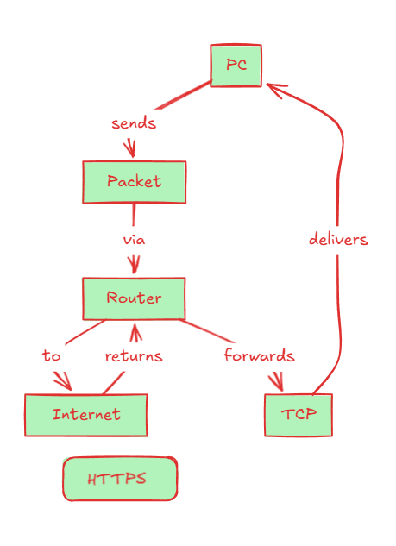

1.2.2 Network Paths and Routing
Draw a simple map showing multiple routes a packet could take to reach a website. Label routers, network paths, and alternative routes.
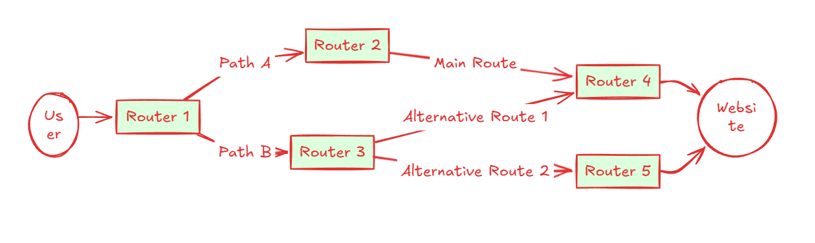
1.2.3 DNS and IP Addressing
Create a diagram showing how DNS works like a phone book for the Internet. Include: domain name, IP address, DNS lookup, resolution, and hierarchical structure.
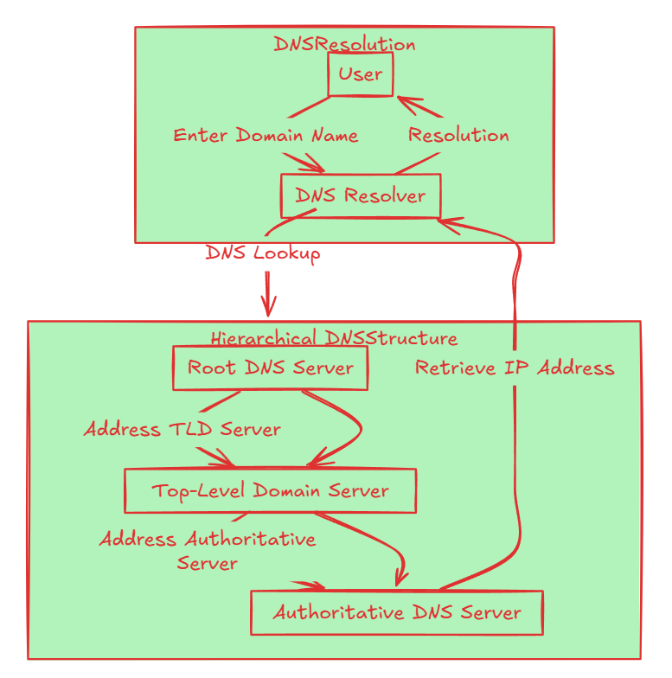

1.3 Cybersecurity

1.3.1 Define encryption and decryption
Encryption is the process of converting plain text data/information into an unreadable format allowing for robust security and confidentiality. Decryption is the reverse process, converting the secure encrypted data into a readable plain text format.
1.3.2 Explain the difference between symmetric and asymmetric encryption.
Symmetric encryption uses the same key which is the public key for both encryption and decryption. It’s much faster and able to take on more load, but as you can imagine it’s less secure since the public key can be intercepted or stolen to decrypt your data. Asymmetric on the other hand uses a public key and private key. You can give your public key to someone to encrypt whatever it is that’s sent to you, but only you can decrypt it with your private key. This is far more secure than symmetric encryption, but it’s slower and handles less data.
1.3.3 Why is encryption important for online security?
The importance of encryption in online security revolves around the fact that obfuscating your plaintext data via robust encryption algorithms and managing your public and private keys properly allows for hardened security and integrity of your data. Anything you send over the internet should always be encrypted.
1.3.4 How do public and private keys work together in encryption?
Since it’s near impossible to derive the private key from the public key, only you can open the messages a corresponding person sends you. This way, even if someone steals the public key, they can’t decrypt the message/data because they don’t possess your private key. Remember that your public key is shared openly. But security will be broken if you use only public keys for encryption, since someone can intercept it and use it to access your files and data.

2 Apply Concepts
🔐 Cybersecurity Game Challenge: Pick Your Path & Learn Key Concepts! 🚀
You're about to dive into cybersecurity through hands-on challenges! Choose a game that fits your interests and experience level. After playing, share your thoughts, results, and new vocabulary you learned!

🔍 Choose One of the following 5 games to explore and learn

Intro Game 🕵️‍♂️ KC7 Cyber Detective → Solve cybercrime cases using log analysis & investigation.
- Concepts & Vocabulary You'll Learn:
🔹 Threat detection – Identifying suspicious activity in logs
🔹 Social engineering – How attackers manipulate people to gain access
🔹 Incident response – Steps taken after a security breach
2.1.1 Complete 1 full case

What was the biggest challenge?
The biggest challenge was analyzing the different types of data available and figuring out how to connect each one to actually run the correct types of queries. Using whatever information I collected to sort of use it and pivot to other clues was a challenge also.
What was your favorite part of the game?
My favorite part was utilizing answers to get to the next answer and clue and learning different types of queries and proper syntax of Kuesto Query Language to run it in Azure Data Explorer. It was fun connecting each answer to get a bigger picture and eventually figure out any threat actor breaches, lateral movement, and motivations/actions.
2.1.2 List and summarize the cybersecurity concepts or vocabulary you learned.
I learned a lot about Kusto Query Language and the basics of SIEM query searches for threat hunting and investigation. I learned that Microsoft Sentinel and Splunk are two of the most widely used SIEMS in enterprise environments, and to optimally hunt threats you must be fluent in the query languages. I learned that SIEMs allow you to connect different containers of data into a centralized overview for advanced threat hunting and gathering evidence.
2.1.3 How can companies or individuals protect against the threats you encountered?
Companies or individuals can protect against the types of threats I encountered by implementing and configuring essential security solutions like Security Information and Event Management (SIEM) systems in place and Endpoint Detection Response (EDR) systems specifically on the host level. It’s also best to train your employees on popular attack methods like phishing emails and what to look out for. They can also get proactive and deploy phishing campaigns. For example, one of the threat actors had compromised the credentials of one of the main company owners, eventually moving on to privilege escalation and lateral movement within the company’s systems. Yet, having these tools allows for you to implement defense in layers giving you more time and advantages to stop the hacker in their tracks and isolate them out.

Intro Game 💻 TryHackMe: Introduction to Cybersecurity → Hands-on cybersecurity fundamentals.
- Concepts & Vocabulary You'll Learn:
🔹 Phishing – Tricking users into revealing credentials
🔹 Encryption – Protecting data using ciphers
🔹 Hashing – Verifying data integrity without storing passwords
🔹 Firewalls – Security barriers to block unauthorized access
2.1.1 Complete the first 3 rooms
What was the biggest challenge?

What was your favorite part of the game?

2.1.2 List and summarize the cybersecurity concepts or vocabulary you learned.

2.1.3 How can companies or individuals protect against the threats you encountered?

Advanced Game 🔐 TryHackMe: Advanced Rooms → Penetration testing, ethical hacking, and OSINT.
- Concepts & Vocabulary You'll Learn:
🔹 Penetration testing – Simulating real cyberattacks to find weaknesses
🔹 SQL injection – Exploiting databases through malicious queries
🔹 Cross-site scripting (XSS) – Injecting malicious scripts into websites
🔹 Privilege escalation – Gaining higher access than authorized
2.1.1 Finish 1 pentesting challenge
What was the biggest challenge?

What was your favorite part of the game?

2.1.2 List and summarize the cybersecurity concepts or vocabulary you learned.

2.1.3 How can companies or individuals protect against the threats you encountered?

Advanced Game 💀 OverTheWire: Bandit → Command-line hacking and privilege escalation.
- Concepts & Vocabulary You'll Learn:
🔹 Command-line navigation – Using Linux/Unix for cybersecurity
🔹 Privilege escalation – Gaining unauthorized admin access
🔹 Brute force attacks – Guessing passwords systematically
🔹 SSH (Secure Shell) – Securely accessing remote systems
2.1.1 Reach Level 5
What was the biggest challenge?

What was your favorite part of the game?

2.1.2 List and summarize the cybersecurity concepts or vocabulary you learned.

2.1.3 How can companies or individuals protect against the threats you encountered?

3 Reflection

Part 3: Reflection
Write a brief reflection on this guided exploration.

3.1.1 What concepts were new to you?
All of these concepts were covered in my previous classes and the certifications I was studying for in the past, but it’s always good to go back and revisit these concepts for a refresher as these are important foundational concepts that you must know before moving onto other advanced concepts.
3.1.2 How does this knowledge apply to real-world cybersecurity?
This knowledge applies to real-world cybersecurity by laying out the building blocks in which systems all around us operate on. As we live on the application layer interacting with the Graphical User Interface (GUI), we’re never really exposed to what’s happening under the surface every time we send an important document over the internet. What’s happening in the background and how important it is to make sure it’s operating adequately is more important than ever in this day and age for robust security.
3.1.3 If you had more time, what would you explore further?
If I had more time, and I probably will continue to explore more just because the KC7 games/rooms was extremely intriguing to me as it was almost like a cat and mouse type of relationship as I had to critically think and analyze where the threat actor started from and how they pivoted throughout the system laterally. The layout of the SIEM and running queries to go from clue to the next clue was satisfying and exciting. I would love to explore other SIEMS and other rooms on the platform.

Read what the deliverables are to be uploaded and due date for this assignment

